# National Seminar: Toward the abolition of the death penalty in Tunisia, 25th June 2020:

|  |
| --- |
| **Opening words** |

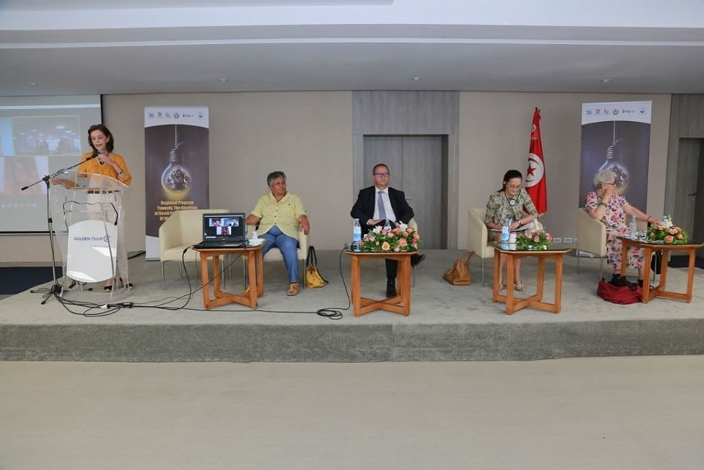

MRS Lamia Grar, the Executive Director of the Arab Institute for Human rights

Today we are attending the first post-quarantine seminar, after a long period in which we were also active through virtual communication techniques; Today's seminar marks the closure of a two-year program organized by the Arab Institute for Human Rights with Hands off Caïn organization and a number of Arab organizations, including the Arab Organization for Human Rights (Egypt) and Somali Women Agenda. Supported by the European Union, the program included several activities and initiatives aimed at the abolition of the death penalty in Tunisia and helping Egypt and Somali to reduce it at an initial stage.

In cooperation with its partners, the Arab Institute of Human Rights had organized a long series of training programs for actors and activists comprised of lawyers, judges and parliamentarians and a number of studies were realized such as the report on death penalty inmates in Tunisian prisons, the comparative research on international, regional and Tunisian law and the draft of basic bill to abolish the death penalty Tunisia.

Elisabetta Zamparutti, Representative of Hands Off Cain Organization

This seminar offers the opportunity to evaluate and share the experiences and results obtained with this Action which took place over 3 years in Tunisia as well as in Egypt and Somalia.

As Hands Off Cain, we won the battle for a universal moratorium on capital executions at the United Nations General Assembly, but the challenge still exists: Advance the abolitionist process and the rule of law and give life to the documents adopted by international organizations. The contribution brought by these Actions has made has been tremendous.

We have never made a study such as the one done by the AIHR in which our partners had met all the condemned to death in Tunisia. It is significant work because for us every action and every initiative are strong and credible if based on actual experiences.

In Somalia, a similar study was carried out in some prisons, while in Egypt, where, for the first time, an NGO, the AOHR, obtained the consensus to conduct visits in prisons. If this result has been achieved, I can say that it is due to the ability to create a relationship of reciprocity between civil society and political decision-makers within the framework of international human rights law. We have encouraged governments, and I hope parliaments, to act on legal changes inspired by international commitments that call for the suspension, abolition, or limitation of the death penalty.

Dozens of meetings, trainings, seminars, workshops were organized with members of parliaments, judges, penitentiary staff, NGOs, journalists in a spirit of collaboration with all targeted groups to strengthen the political voices that are currently in the minority.

The strength of our actions appears in the fact of been able to build alliances with all international, regional and national organizations working for human rights, these universal values, which are the non-violent alternative to all extremism, violence, and reactionary regression. The Action will end but the experiences and results we have gained must be disseminated and strengthened more and more.

Working with the Arab Institute of Human rights made us think about the state of emergency related to terrorism. And in the face of the experiences and the results obtained we have understood that it is possible that in an “emergency state” to emerge consciousness. It is on the elevation of this consciousness that we must continue to build.

* Elodie Cantier Aristide, representative of the Office of the United Nations High Commissioner for Human Rights, Tunisian Bureau

The death penalty was always a cruel and inhumane punishment that neglected the dignity of the human being. it is a simplistic response to complex problems

Calling for its abolition at various levels is certainly a task against public opinion and political agendas, but it remains a good initiative that the High Commissioner for Human Rights welcomes and encourages. The studies and projects carried out on this subject bear witness to the impact of this cruel punishment. this day thus marks another step in the process of abolition of the death penalty.

* Halima Jouini, member of the Arab Institute for Human Rights

We have started thinking about abolishing the death penalty since Gafsa operation, therefore, and in 1985, the feminist movement has fought against the execution of the death penalty, which was and still is a major battle for the human rights activists and feminist movement in Tunisia. The death penalty has always been a discriminatory penalty, which is judged on class, social and political grounds, which is an offense to human rights and to the fundamental right to life.

* Dr. Hafidha Chekir

The fight for human rights inevitably passes through the right to life because it is the essence of all other rights. In the first phase, we will present during the seminar, the studies done and the arguments against death penalty which were our first step in this program, then we had trainings with a number of activists and actors on this punishment, and in a second stage, we presented a bill to abolish it. So today we are here to discuss all our mechanisms for action in the next phase.

* Abdel Basset Ben Hassan, president of the Arab Institute for Human Rights

In each seminar, I recall an important history: The 1993 seminar, which was an important opportunity to study the relationship between the cultural, religious, civilizational dimensions and the death penalty, and which made us work on arguments to abolish it.

The Arab Institute for Human Rights and its partners have contributed to the suspension of the execution of the death penalty in Tunisia, which represents a major breakthrough in this battle, and in which we believe we will win in the last.

What we have in common with our partners is the continuous work on the defense of human rights under a universal context known by the violation of rights such as the right to the environment, the right to the public institutions, and others. One of the dreams we have realized today is the ”Essaida” radio, which can deliver a media speech that will contribute to further increase the consciousness on human rights issues.

|  |
| --- |
| **First Session: The right to life and the death penalty in international and comparative law** |

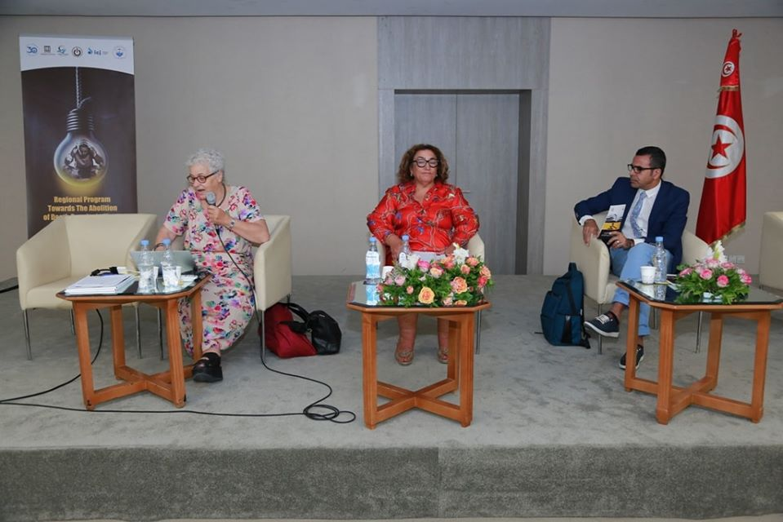

Presented by DR. Hafidha Chekir and Dr. Wahid Ferchichi

The session was an opportunity to Present and discuss the Study on the right to life and death penalty in international law, comparative law and Tunisian law:

Tunisia has ratified several international conventions, which are a part of its legal system. This last must be revised in order to conform to the former conventions.

International conventions:

* International Covenant on Civil and Political Rights (1966): The Covenant emphasizes the importance of the right to life, in its 6th article which recognizes and protects the right to life of all human beings as the supreme right from which no derogation is permitted even in situations of armed conflict and other public emergencies which threatens the life of the nation. but it has left the possibility of sentencing to death for serious crimes under a final judgment of a special court.
* The 1989 Optional Protocol: The 1989 second Optional Protocol is a side agreement to the International Covenant on Civil and Political Rights which prohibits the execution of any person and requires States to ratify, took the necessary measures to abolish it. Tunisia did not ratify this protocol.
* The Rome statute of the International Criminal Court: The death penalty was not included in the penalties for crimes against humanity, war crimes, genocide, and aggression crimes. The Tunisian state has ratified this Convention.
* Conventions related to international humanitarian law: Two protocols recognize that the death penalty can only be applied in extreme cases.

**Regional conventions:**

* US Convention: Provides for the right to life, and it has retained the death penalty for the most serious crimes and in 1990 the penalty was abolished completely.
* African Charter: admits The right to life and prohibits arbitrary deprivation of life and the execution of a person without trial or respect for the minimum rules of defense and recognizes that the inviolability of the human person and the right to respect for his or her life and physical and moral integrity are inviolable and that every child has the right to life. It also prohibits the imposition of death sentences in crimes committed by children. The Protocol to the Convention addressed the right of women to respect their life and security and the non-application of the death penalty to pregnant and nursing mothers.
* Arab Charter for Human Rights: The Arab Charter protects the right to life without abolishing the death penalty leaving the possibility of death sentences for high-risk crimes and preventing the death sentence against children and the non-execution of such sentences against pregnant or nursing women.

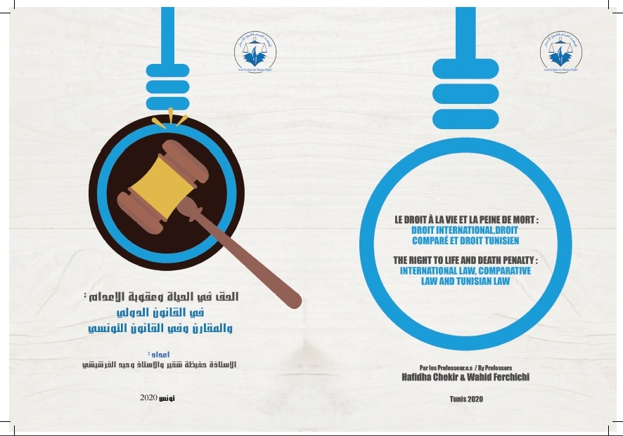

**Discussion:**

* Currently, despite the difficult circumstances known as the spread of terrorism in the world, countries are taking steps toward abolishing the death penalty and Tunisia should be so.
* The solution is to increase awareness among citizens to create generations of strong people aware of their rights.
* 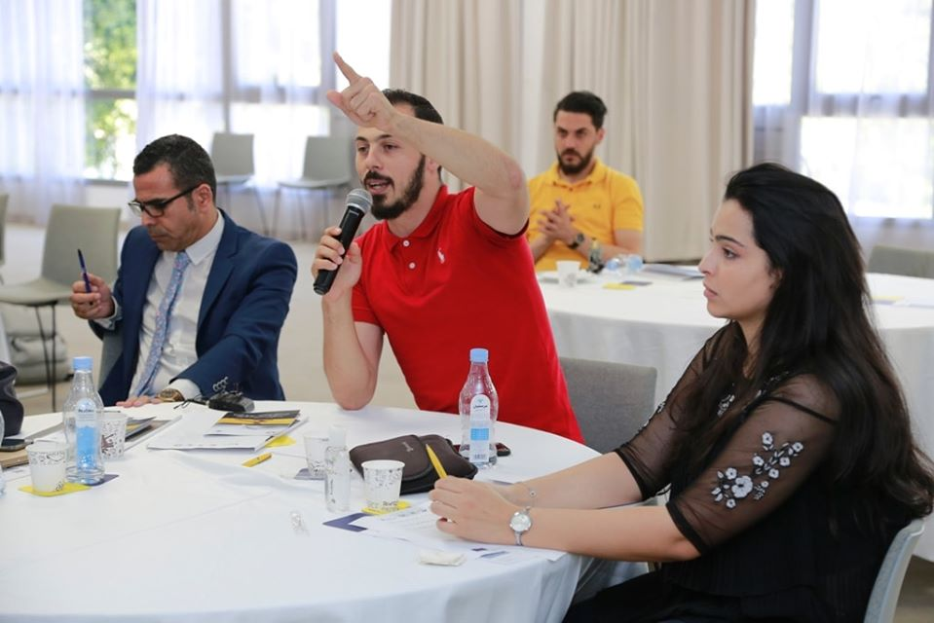

|  |
| --- |
| **Second part: A draft basic law on the abolition of the death penalty** |

Presented by Dr. Hafidha Chekir and Dr. Wahid Ferchichi

The bill is a work in which many have contributed, and a text directed to the decision-makers, not to the general public, which has emerged from the main idea that it is insidious to maintain as a democratic state which respects human rights such a punishment. Especially with the fact that we had abolished all other punishments related to Religious legislation.

**Reasons explanation:** The death penalty:

* Is based on intimidation,
* Is incompatible with the intellectual and scientific foundations of the human rights system,
* Is not intended to reform and rehabilitate the sentenced person,
* It cannot repair the effects of the penalty if the convicted is proven innocent after the execution,
* Is particularly present in authoritarian regimes and was always associated to political crimes,
* Is in no way compatible with the principle of respect for the physical and moral inviolability of individuals,
* It ignores the right to life, which is a natural right,
* Is unconstitutional.

**The bill of law**: A short law containing four chapters, the first stipulates for the sanctity of the right to life; The second provides for the abolition of the death penalty and its deletion from all laws in force in Tunisia. In the third chapter, the law calls for changing it with other penalties ranging from 20 years to higher penalties. Chapter IV covered the need for this law to apply retroactively and to include all published courts.

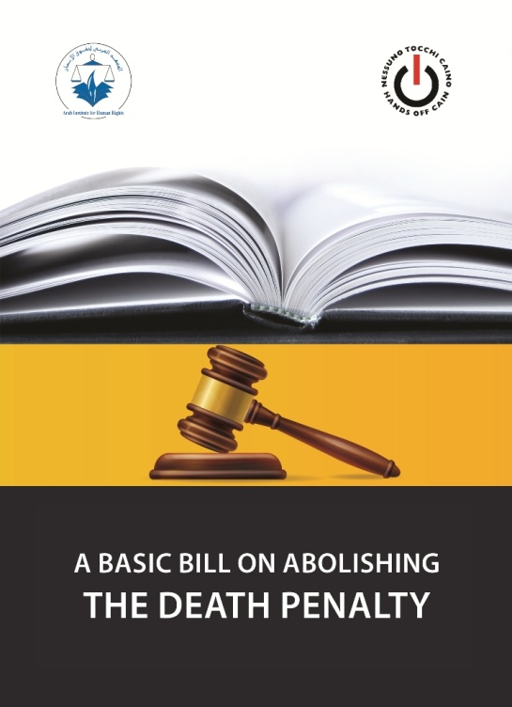

**Discussion**:

* The question today is whether we have the interest to present the bill of law individually or its more effective to join it in the Journal of individual Rights and Freedoms.
* Lawyers and judges must be convinced that this punishment does not eliminate violence.
* The medical committee should have a varied composition, with representatives from civil society, psychologists, and specialized medical staff.
* The answer to the argument that the criminal should not be considered as human after committing such horrifying crime, first of all, no one can really define these very heinous cases and then the state is reasonable and does not think emotionally
* We must be aware that civil society does not reflect the expectations of society, and that the State's commitment to human rights education, sensitization and education must be considered.
* The State has no right to take life, however, it has to incubate its citizens and protect their rights.
* We must also work on racism and minorities in relation to this penalty.

|  |
| --- |
| **Second session**: **The death penalty in Tunisia: Is stopping execution enough?** |

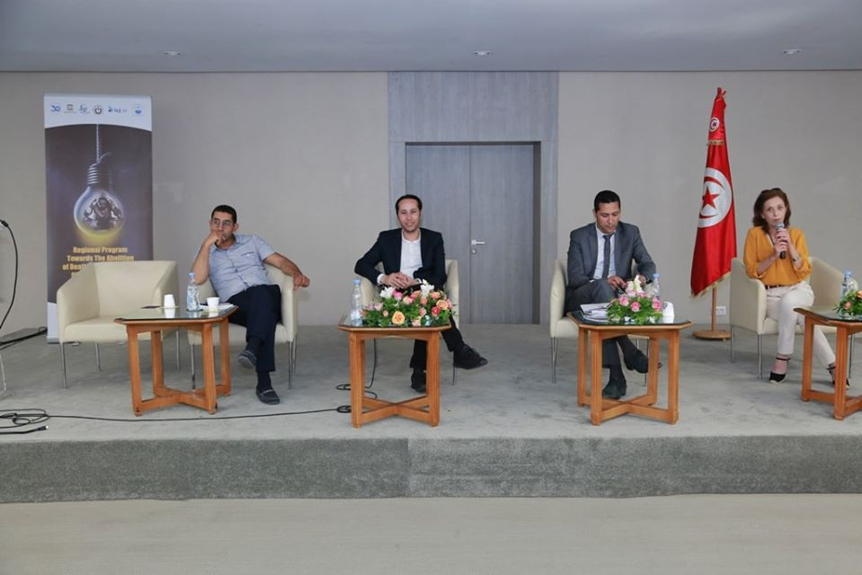

Presented by Mr. Khaled Mejri

Conducted by Mr. Bassem Amri

The study was conducted in cooperation with the Arab Institute for Human Rights, the Tunisian Coalition for the Abolition of the death penalty, and the Tunisian League for the Defense of Human Rights. The study, in its main part, conducted interviews with those sentenced to death in Tunisian prisons between February and September 2018 and was based on information from the Ministry of Justice concerning the prisons in which the sentenced were imprisoned. During these interviews, the researcher team followed the same approach and held meetings with prison directors, a group of staff, gathering information about prison institutions, and then went to private individual interviews with the sentenced persons and without the presence of representatives of the prison administration. The interviews included all final death sentence clauses and then the pieces of information collected through a standardized questionnaire were analyzed quantitatively and quantitatively. The study was the first one in the Arab world, to include all those sentenced to death in Tunisia during the period from February to September. Three other categories of persons in connection with the death penalty, which are judges, lawyers, and officials of the prison establishment, were also concerned through individual meetings and focus groups of each category, and the results of all these meetings were examined and summarized into conclusions.

The total number of persons sentenced to death in Tunisian prisons is 53 persons distributed in the following prisons: Morneguia, Burj Al Ameri, Mannouba, Kef, Kasserine, Sidi Bouzid, Mahdia, Sfax, Al-Nadour and Burj Al-Roumi, of whom 50 are convicted of crimes of general right and only 3 are sentenced to terrorist crimes.

The cases in which death sentences are imposed are murder, and participation in the murder. Here, we can note that there was a huge expansion of the definition of the crime of participation in murder.

Data on sentenced to death persons:

* 6% of the sentenced were women and 94% were men
* They are between 20 and 40 years old
* A significant number of them were family members and had children
* 60.5% were single, 30,7% were widows, 26.4% were married, and 9.4% of them were divorced.

Their position on the death penalty:

* 4% had no opinion
* 63% were against the death penalty
* 33% of them agreed with the death penalty.

The position of workers in prison institutions regarding the death penalty: The majority had shown a primary refusal of the death penalty.

Judges' position on the death penalty: A large group of them was with the penalty being maintained against a small group, who was with the abolishment of the penalty.

Lawyers' attitude toward death penalty: A group of them considers it a punishment prescribed by statutory law, another group believes that carrying this penalty from the Tunisian legislator has become unconstitutional and a third group believes that these sanctions should remain but in exceptional cases, and must be restricted in a narrower definition than it is today.

The study was based on two axes:

**1. The process to death penalty:**

* Institutional factors: The disadvantages of the judicial system in all its aspects (investigation and prosecution)
* Social factors: Among the factors examined during this research were the social factors of the sentenced to death, including the contribution of economic and social status to crime and the responses were as following: 46% of them think that economic issues are not related to the crime they have done, 42 % think that economic issues had a real effect in committing the crime and 12 % of them did not find a link between crime and Economic and social development. Social fragility can also be considered as an important factor because it is combined with poverty.

**2. Life after being sentenced to death**

* The right to dignity: We have noticed some violence in dealing with those sentenced to death.
* Health care issues: psychological medicine is easily given to those sentenced to death prisoners.
* The right to practice religious rites, a problem that is generally associated with prison culture.
* The right to communicate with the family and the outside environment: 90% of them receive visits at a different pace
* The right to education and composition: Absence of enabling mechanisms.

**Discussion:**

* Such studies emphasize the need to spread the culture of human rights in all categories, especially prison institutions.
* Punishment must withdraw freedom and not withdraw dignity.
* After being sentenced to death, prisoners are no more connected to the outside world.
* Lawyers do not make a sufficient effort when pleading.
* We must examine prison institutions through research and further explore the causes of the crimes.
* Maher Manai, the proven innocent, sentenced to death, has attempted suicide 14 times in jail.
* Those sentenced to death in Tunisia are not serial killers or gang leaders, and most of their crimes are passion crimes.
* 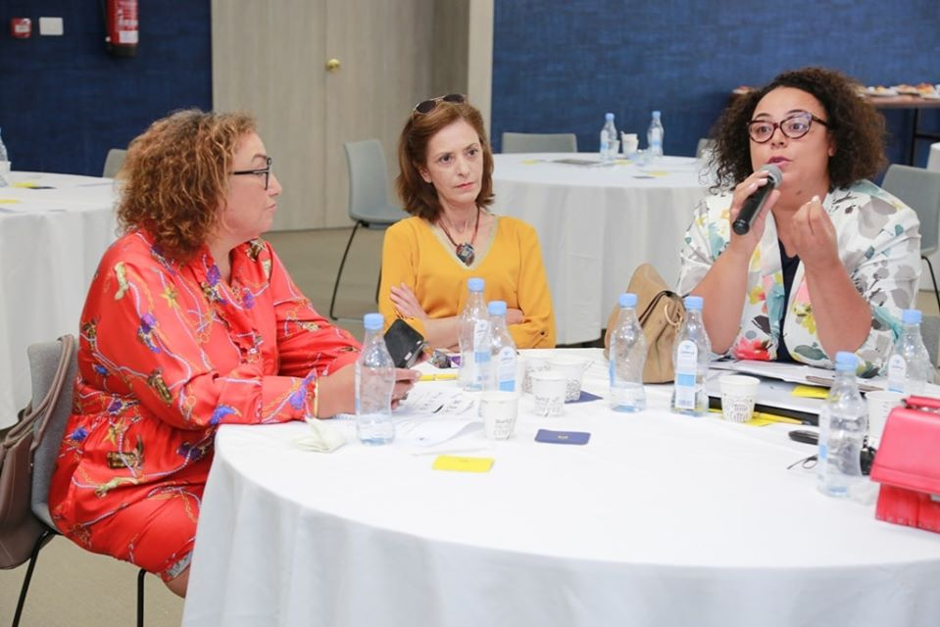

|  |
| --- |
| **Third Session**: **How to proceed to advocate for the bill on the abolition of the death penalty in Tunisia** |

Conducted by Judge Omar Oueslati

* Media should be used to spread the issue to the widest extent, making a video or a radio broadcast in ESSAIDA radio can express the idea in a simple manner.
* A flyer should be prepared in which we would publish clear arguments against the death penalty that can impact people.
* It is important to be public-oriented, but we must also target decision makers by defining our intentions of ratifying the bill alone or, rather, to incorporate it in the Journal of individual rights.
* We must begin by identifying the ones who can influence decision-makers.
* With society refusing to abolish the penalty, it is better to work with an indirect methodology to raise awareness.
* We have to develop our arguments against the death penalty. There are other excuses other than religious justifications that we must work to refute
* The advocacy must be launched before the revealing of the revised Criminal Code and must go through all official government bodies at the same time to intensify the chances of accepting it.
* Artists can provide help by communicating the matter effectively and largely.
* We must define the right time to go before starting our advocacy.
* First, the youth of civil society must be persuaded to abolish this penalty in order to be able to do so.
* We can make a film about Maher Manai’s case, which can have a great impact on public opinion.
* There are parallel paths between the community, the legal, and the institutional path all of them are important to us to enhance our success rate. It is also important to work internally and externally, As the state is required to adapt laws that conventions ratified.
* We must work more with media and journalists which are key partners that can have a large contribution to the advocacy. A TV-program talking about each case of those sentenced to death can be a good idea to influence people’s view.
* We can have a monthly meeting where we can discuss effectively how to proceed step by step to make a successful campaign.
* We must reach the interior regions by small and popular steps to increase our success rate.